SIGNFLIX: A VIDEO STREAMING PLATFORM

WITH SIGN LANGUAGE

Mrs. Nayana Yadav M, Jnanesh, Himanshu Hegde, Gauresh G Pai, Milan C I

Department of CSE, AJIET, Mangaluru

***Abstract*:** Ensuring accessibility for all users, including the deaf and hard-of-hearing community, has become a top priority in an era of rising digital media consumption. Captions are frequently used on traditional video platforms, but they are not enough to offer a completely inclusive experience. SignFlix presents a novel solution: a video streaming service that incorporates sign language interpretation by using external APIs to process captions. The system architecture, upcoming features like dual video playback and user-controlled synchronization, and SignFlix's overall influence on fostering digital inclusivity are all examined in this paper. SignFlix seeks to close the accessibility gap in popular media platforms by emphasizing automation, scalability, and user experience.

***Keywords*:**  Sign Language, Accessibility, Video Streaming, Digital Inclusion, Caption Processing, Sign Language Translation, User-Centered Design

## INTRODUCTION

SignFlix is a web-based video streaming platform developed to address the significant gap in accessibility for the deaf and hard-of-hearing community. While captions have become a common accessibility feature, they do not fully convey the richness and nuances of sign language, which is a primary mode of communication for many deaf users. SignFlix enhances accessibility by enabling the integration of sign language interpretation into video content through the use of external APIs that convert captions into sign language simulations.

The platform is designed with a dual-interface model, catering to both content creators and viewers. Creators can upload captioned videos, which are then processed for sign language rendering. Viewers are provided with features such as dual playback (original and sign language video), adjustable playback speed, and customizable synchronization delay, giving them control over how they consume content.

Built using modern web technologies and optimized for cross-device compatibility, SignFlix delivers a responsive and user-friendly experience. Its backend architecture is scalable and modular, allowing future expansion such as support for multiple sign languages, mobile access, and interactive educational features. The platform aims not just to stream content but to set a standard for digital inclusivity in media.

## LITERATURE REVIEW

The shift toward inclusive and accessible media platforms is increasingly emphasized in contemporary research. Sabharwal and Singla (2023) discussed the complexities of translating Indian Sign Language (ISL) into text, highlighting challenges like grammar inconsistencies and limited datasets. Their findings stress the importance of context-aware, linguistically grounded solutions—principles central to SignFlix's support for regional sign languages.

Rashmi et al. (2023) surveyed recent advances in ISL recognition,

evaluating deep learning techniques such as CNNs and HMMs. Their work reinforces the role of transfer learning and real-time processing in gesture-based systems, aligning with SignFlix’s aim to deliver seamless sign language simulations through caption-driven API integration.

Bragg et al. (2007) offered a comprehensive, interdisciplinary perspective on sign language technologies, addressing recognition, generation, and ethical design considerations. Their emphasis on involving the Deaf community and addressing regional variations directly informs SignFlix’s vision for a flexible, user-centered platform that adapts across linguistic and cultural contexts.

METHODOLOGY

SignFlix was developed following the Agile methodology, ensuring flexibility, iterative progress, and user-centered development. The process began with requirement gathering through discussions with accessibility advocates, deaf community representatives, educators, and video content creators. These sessions helped define user expectations around video accessibility, sign language support, and content personalization features.

The design phase focused on developing intuitive user interfaces and playback controls using tools like Figma. Wireframes and high-fidelity prototypes were created for key user journeys, including video uploading, caption processing, and sign language playback control. Continuous feedback from target users shaped the design iterations.

Development was executed in sprints, with each sprint delivering core features such as caption extraction, API-based sign language conversion, dual video rendering, and playback synchronization controls. Each sprint concluded with a demo, stakeholder feedback, and backlog refinement. Automated unit and integration tests ensured system reliability, while manual testing covered edge cases related to media performance and user interactions.

A secure and automated CI/CD pipeline using GitHub Actions facilitated consistent deployment. The pipeline integrated automated testing, static code analysis, and rollback mechanisms for fault tolerance. Post-deployment, the system is continuously monitored using tools like Grafana and LogRocket, while feature updates are informed by real-time analytics, user behavior data, and feedback from embedded support channels.

This methodology ensures SignFlix remains adaptive, reliable, and aligned with the evolving needs of its users.

SYSTEM DESIGN AND IMPLEMENTATION

Caption-to-Sign Language Conversion Workflow

SignFlix employs a structured pipeline to convert video captions into sign language visualizations. The process is designed to be flexible and scalable, using API-based services for real-time translation.

* Caption Processing: Uploaded videos with embedded or separate caption files (e.g., SRT, VTT) are parsed to extract text along with timestamps.
* Text-to-Sign API Integration: Extracted captions are sent to a third-party or in-house sign language API, which converts the text into a sequence of sign language gestures, often in the form of animated avatars or pre-rendered videos.
* Timestamp Synchronization: The generated sign language data is aligned with the original video timeline using metadata for accurate parallel playback.

This architecture enables automated, scalable sign language support for a wide variety of content.

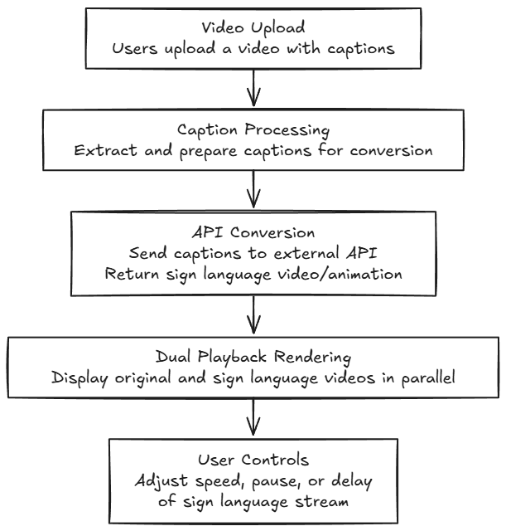

Dual Video Streaming and Playback Control

SignFlix incorporates a dual-stream video player to allow users to view the original content alongside its sign language interpretation.

* Parallel Display: The primary video and sign language stream are played side-by-side or picture-in-picture, depending on user preference.
* Adjustable Delay: Users can fine-tune the time offset between the two streams to accommodate personal comprehension speeds.
* Independent Playback Controls: Pause, play, and speed controls can be applied individually to either stream for a customizable viewing experience.
* Adaptive Design: The interface adjusts to various screen sizes and devices to ensure usability across desktops, tablets, and smartphones.

This feature ensures that viewers can consume content in a way that best suits their communication needs.

CONCLUSION

SignFlix represents a forward-looking solution in the domain of accessible digital media, specifically designed to overcome the limitations of conventional video streaming platforms in serving the deaf and hard-of-hearing community. By incorporating automated sign language interpretation through caption-to-sign processing, SignFlix ensures inclusive access to video content while reducing reliance on manual interpretation or static captioning alone.

The platform’s user-centric approach enhances the experience for both creators and consumers. Content creators benefit from a streamlined upload process and automated accessibility integration, while users gain control over their viewing experience with features such as dual-stream playback, delay adjustment, and independent playback of sign language. This adaptability empowers individuals with varying communication needs to engage with content in a personalized, inclusive manner.

Early testing and stakeholder feedback affirm the platform’s practical value, particularly in educational and informational content contexts. SignFlix has the potential to elevate institutional credibility by demonstrating a commitment to digital accessibility and inclusion. Its application extends to schools, universities, content platforms, and public information services aiming to comply with accessibility standards and better serve diverse audiences.

Developed using an Agile methodology, SignFlix is engineered for continuous improvement. This flexible approach ensures the system evolves based on real-world usage and advances in language processing and accessibility technologies. The platform's modular structure supports the integration of additional features—such as support for multiple regional sign languages, AI-based quality evaluation, and mobile accessibility—without disrupting core functionality.

Future development will focus on expanding the platform’s reach and utility, including support for community-contributed translations, customizable avatar-based interpretation, and integration with learning management systems (LMS). These enhancements position SignFlix as a scalable, inclusive, and future-ready platform that redefines how accessible video content is produced, delivered, and experienced.

## REFERENCES

**[1]** Camgoz, N. C., Koller, O., Hadfield, S., & Bowden, R. (2020). Sign Language Transformers: Joint End-to-End Sign Language Recognition and Translation. In Proceedings of the IEEE/CVF Conference on Computer Vision and Pattern Recognition (CVPR), 10023–10033.

**[2]** De Coster, M., Shterionov, D., Van Herreweghe, M., & Dambre, J. (2021). Machine Translation from Signed to Spoken Languages: State of the Art and Challenges. ACM Computing Surveys (CSUR), 54(12), 1–36.

**[3]** Seddik, B., & Essoukri Ben Amara, N. (2021). Visual Methods for Sign Language Recognition: A Modality-Based Review. Multimedia Tools and Applications, 80(1), 485–520.

**[4]** Madhiarasan, M., & Roy, P. P. (2022). A Comprehensive Review of Sign Language Recognition: Different Types, Modalities, and Datasets. Journal of Ambient Intelligence and Humanized Computing, 13, 3083–3102.

**[5]** Rashmi, J., Sahani, S., & Yadav, P. K. (2023). Advances in Indian Sign Language Recognition: Techniques, Models, and Applications. In 2023 International Conference on Computational Intelligence and Data Science (ICCIDS).

**[6]** Sabharwal, S., & Singla, P. (2021). Translation of Indian Sign Language to Text: A Comprehensive Review. In 2021 International Conference on Machine Learning and Big Data Analytics for IoT Security and Privacy.

**[7]** Rao, M. K., Kaur, H., Bedi, S. K., & Lekhana, M. A. (2021). Image-Based Indian Sign Language Recognition: A Practical Review Using Deep Neural Networks. In 2021 6th International Conference on Communication and Electronics Systems (ICCES).

**[8]** Ciocan, C. S. R., & Butincu, C. N. (2023). Sign Language Accessibility in Digital Media Platforms: A Systematic Review. International Journal of Human–Computer Interaction, 39(5), 412–428.

**[9]** Wang, W., & Yin, J. (2022). Real-Time Sign Language Recognition and Translation with 3D Pose Estimation. Sensors, 22(14), 5361.

**[10]** Tan, Z., & Yu, H. (2023). Deep Learning Models for Sign Language Recognition: From Static to Continuous Signing. IEEE Access, 11, 43709–43722.